

**“STUDENT COUNCIL VOTING”**

**A PROJECT REPORT SUBMITTED TO GOA UNIVERSITY IN PARTIAL FULFILLMENT OF THE REQUIREMENT FOR THE DEGREE OF BCA**

**BY**

**Mr. Aaron Dias**

**Mr. Kritesh Pednekar**

**Mr. Poorvang Mesta**

**Mr. Raj Bagkar**

**Mr. Rajat Bandekar**

**Mr. Saiesh Velip**

**Mrs. Vinita Naik**

**Mr. Vaibhav Shinde**

**ASST. PROF. Vaishanvi Mishal** **MS. GAURI DESSAI** **DR. MANASVI KAMAT**

**INTERNAL GUIDE** **PROJECT COORDINATOR** **PRINCIPAL**

**Murgaon Education Society**

**M.E.S. COLLEGE OF ARTS & COMMERCE ZUARINAGAR**

**GOA – 403 726**

**DEPARTMENT OF COMPUTER APPLICATION**

**2021-2022**

I

**DECLARATION BY CANDIDATES**

We declare that this project report has been prepared by us to the best of our knowledge, it has not previously formed the basis for the award of any diploma or degree by this or any other University.

| **Roll No** | **Name** | **Signature** |
| --- | --- | --- |
| BCA20001 | Aarone Dias |  |
| BCA20009 | Kritesh Pednekar |  |
| BCA20017 | Poorvang Mesta |  |
| BCA20021 | Raj Bagkar |  |
| BCA20022 | Rajat Badnekar |  |
| BCA20026 | Saiesh Velip |  |
| BCA20038 | Vinita Naik |  |
| BCA20123 | Vaibhav Shinde |  |

**Date:**

**Palace: Zuarinagar**

**II**



**Murgaon Education Society**

**M.E.S. COLLEGE OF ARTS & COMMERCE ZUARINAGAR GOA – 403 726**

**DEPARTMENT OF COMPUTER APPLICATION**

**Affiliated to Goa University**

**CERTIFICATE**

This is to certify that a project on

**‘Student Council Voting’**

Has been successfully completed by

**Mr. Aaron Dias**

**Mr. Kritesh Pednekar**

**Mr. Poorvang Mesta**

**Mr. Raj Bagkar**

**Mr. Rajat Bandekar**

**Mr. Saiesh Velip**

**Mrs. Vinita Naik**

**Mr. Vaibhav Shinde**

Studying in T.Y.B.C.A. during the academic year 2021-2022.

The project has been carried out under the supervision of the internal guide(s).

| Asst. Prof. Johann Rodrigues |  | Ms. Gauri Dessai | Dr. Manasvi M. Kamat |
| --- | --- | --- | --- |
| (Internal Guide) | (External Examiner) | (Project Coordinator) | (Principal) |

Place: Zuarinagar

Date: 18-05-2022

**III**

**ACKNOWLEDGEMENT**

While bringing out this project to its final form, we came across several people whose contributions in various ways helped our field of research & they deserve special thanks it is a pleasure to convey our gratitude to all of them.

First and foremost, we would like to express sincere thanks to **Dr. Manasvi M Kamat**, principal, M.E.S college of arts and commerce. Zuarinagar-goa for allowing us to take up this project work.

We are thankful to **Ms.Gauri Dessai** , coordinator of the BCA department , MES college of arts and commerce for extending support to complete the project effectively.

We express our sincere gratitude to **Assistant Prof. Vaishanvi Mishal** MES college of arts and commerce, Zuarinagar -Goa for helping us to complete our project.

Especially we are thankful to our families for financing and supporting our education & our friends and for giving us their valuable time to give suggestions.

We are thankful to other professors, friends of our college for all the assistance rendered in their capacities

**IV**

**Table of Content**

TITLE PAGE…………… I

12

Checkout Page 13

Contact us page 13

About us page 14

V

Chapter 7: Gantt chart

7.1 Gantt chart diagram 15

Chapter 8: System Testing

7.1 Why system testing is needed 22

7.2 Testing Strategy 23

7.3 Validation Testing 24

7.4 Validation Testing report 25

Chapter 9: Conclusion

8.1 Conclusion 26

8.2 Future aspect 29

**VI**

**Chapter One**

Introduction

**1.1 Overview**

Student council voting website is an online platform that facilitates the election of student council representatives. It provides a digital way for students to nominate and vote for their preferred candidates, making the process more accessible and efficient.

**1.2 Background Study**

E-commerce is fast gaining ground as an accepted and used business paradigm. More and more business houses are implementing web sites providing functionality for performing commercial transactions over the web. It is reasonable to say that the process of shopping on the web is becoming commonplace.

The objective of this project is to develop a general-purpose e-commerce store where any product (such as books, CDs, computers, mobile phones, electronic items, and home appliances) can be bought from the comfort of home through the Internet. However, for implementation purposes, this project will deal with an online ecommerce cosmetic store.

An online store is a virtual store on the Internet where customers can browse the catalog and select products of interest. The selected items may be collected in a shopping cart. At checkout time, the items in the shopping cart will be presented as an order. At that time, more information will be needed to complete the transaction.

Usually, the customer will be asked to fill or select a billing address, a shipping address, a shipping option, and payment information such as a credit card number. An email notification is sent to the customer as soon as the order is placed.

**7**

**1.3 Project Planning**

Planning a project is a component of project management, which refers to the application of schedules, such as Gantt charts, in order to plan and then report on the status of progress made within the context of the project environment. At the outset, both the scope of the project and the relevant procedures for completing the project are outlined. After this phase, a work breakdown structure is created by listing the times required for the various tasks that are required to finish the work and then grouping those times together. In order to define the logical relationships that exist between jobs, an activity network diagram is utilized. This model makes it possible to locate the critical path. After that, an estimation of the required resources can be made, and the costs of each activity may be assigned to the appropriate resource; this will result in the final cost of the project. At this point in the process, the project plan may be optimized in order to achieve the necessary balance between resource utilization and the duration of the project in order to conform to the project objectives.

Page

**Chapter Two**

Existing system

In the model of cosmetic stores that are now in use, the store is an offline retail location where sales and purchases take place only when consumers come to the store in person to make their purchases of the products that they wish to purchase.

In this business model, a significant portion of sales was contingent on the physical locations of offline businesses and the number of individuals who lived in close proximity to those stores, both of which had a direct bearing on the amount of merchandise that was sold.

In this particular model, there was a time limit placed on sales, which was partly caused by the shop's predetermined business hours. Both the consumer and the vendor encountered various challenges of this nature.

Page



**Chapter Three**

**Proposed system**

In the proposed model we have created an online E-commerce website that will digitalize the whole business of selling cosmetic products. The website we have made has been divided into subsections from which the customer can choose what type of product they want and the website also suggests the best selling product which helps the customer to make more informed choices to select the best product according to their needs.

We have also added the filter of segregating the products according to the price so that it will show only the products which are in the price range of the customer. We have added the facility of online payment through credit/debit or internet banking which will make the whole experience of the website very smooth.

To increase our offline sales as well we have added a map and phone number in the “About Us” section which will help the customers to know where the retail store is and can also go and buy the product by personally going to the shop. The advantage of our E-commerce website is that it will speed up the buying process and will save time for the customer. It will help in easy re-targeting of customers with the help of mails, Google, and Facebook ads. It will also promote impulse shopping as buying the product in this method is very easy.

Ecommerce allows us to use more advanced technology, such as digital marketing. Content marketing, SEO, affiliate marketing, email marketing, pay-per-click marketing, affiliate marketing, and social media marketing are all examples of this. Each of these activities is less expensive than typical sales approaches and can help you earn more money. Furthermore, they communicate directly with potential clients who frequently utilize social media, increasing word of mouth.

E-commerce allows us to sell to people not just in our own country, but also around the world. Selling goods worldwide not only boosts your credibility but also gives access to a previously unexplored market. We can make a sale almost anywhere and at any time. It also minimizes human error. From managing the store to billing the customers, the possibility of errors is lowered considerably. With the help of the e-commerce website the store will always be online, hence sales will be happening 24*7 throughout the world hence increasing the revenue exponentially.

Page

**Chapter Four**

**System Design**

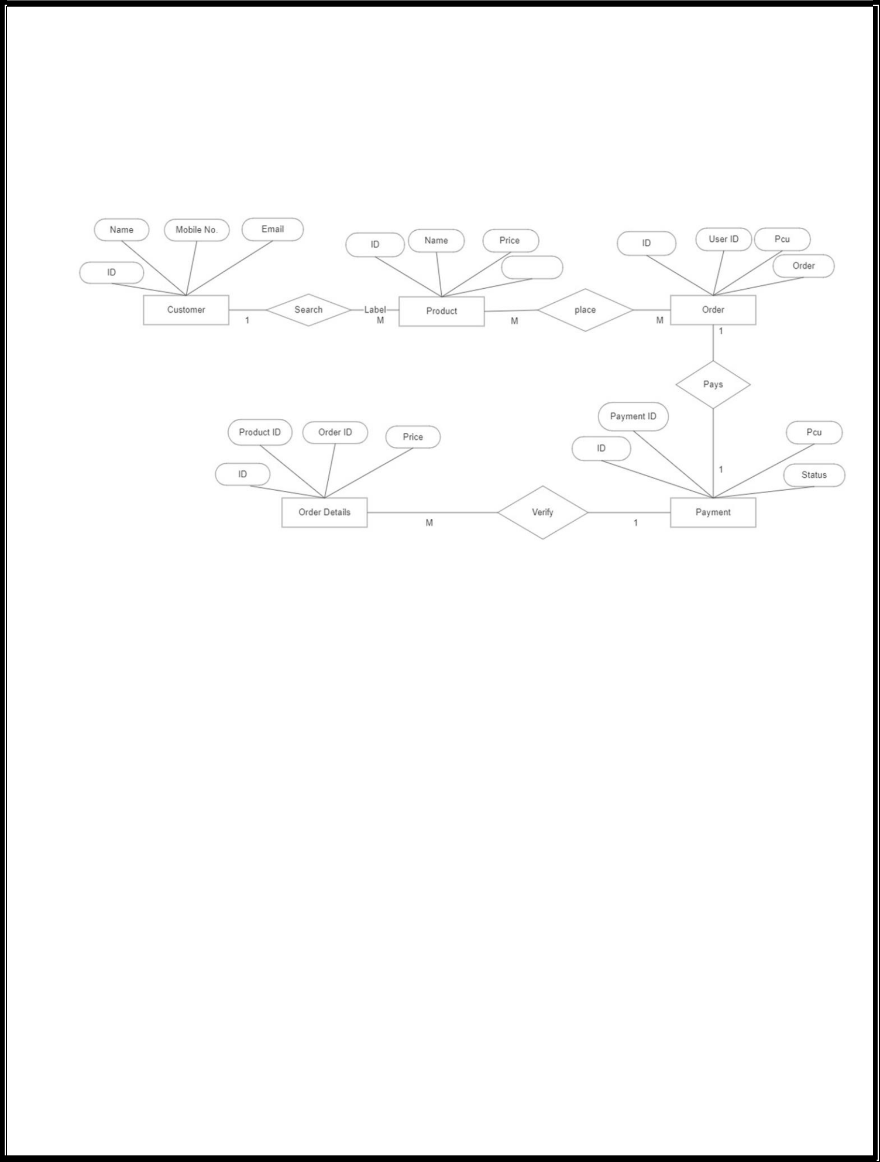

**2.1. Entity Relationship Diagram**

**Fig 2.1**

An Entity Relationship (ER) Diagram is a type of flowchart that illustrates how “entities” such as people, objects or concepts relate to each other within a system. ER Diagrams are most often used to design or debug relational databases in the fields of software engineering, business information systems, education and research. Also known as ERDs or ER Models, they use a defined set of symbols such as rectangles, diamonds, ovals and connecting lines to depict the interconnectedness of entities, relationships and their attributes. They mirror grammatical structure, with entities as nouns and relationships as verbs.

Page

**2.1 Flow chart Diagram**

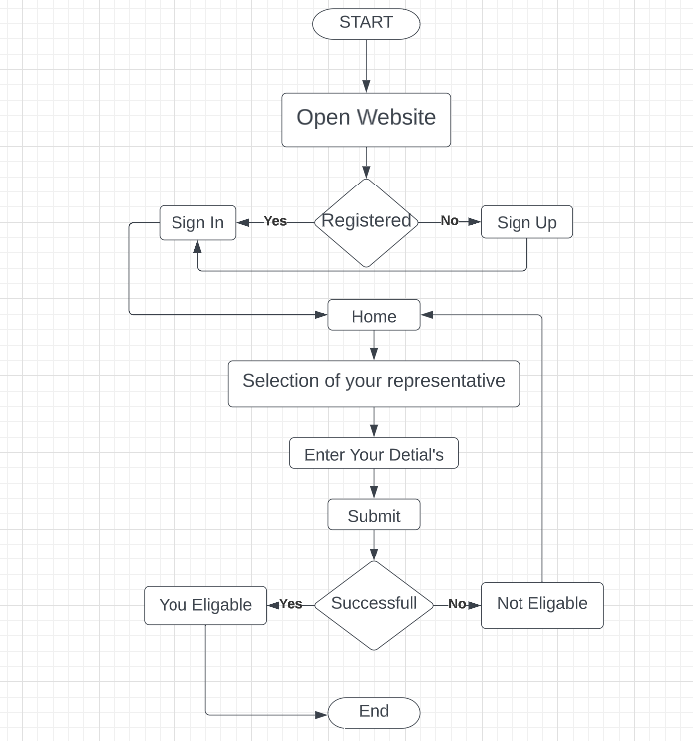

**Fig 2.2**

Page

**2.2 Use case diagram**

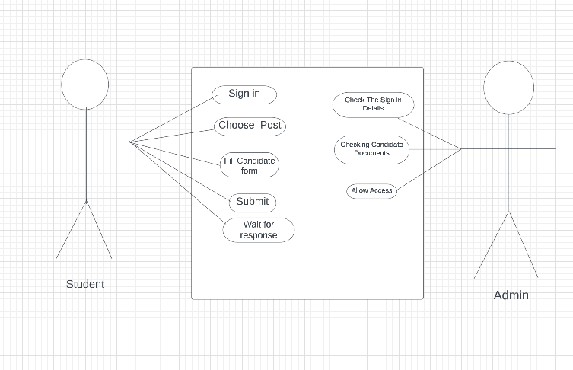

**Fig 2.3**

In the Unified Modeling Language (UML), a use case diagram can summarize the details of your system's users (also known as actors) and their interactions with the system. To build one, you'll use a set of specialized symbols and connectors. An effective use case diagram can help your team discuss and represent:

* Scenarios in which your system or application interacts with people, organizations, or external systems
* Goals that your system or application helps those entities (known as actors) achieve
* The scope of your system

Page

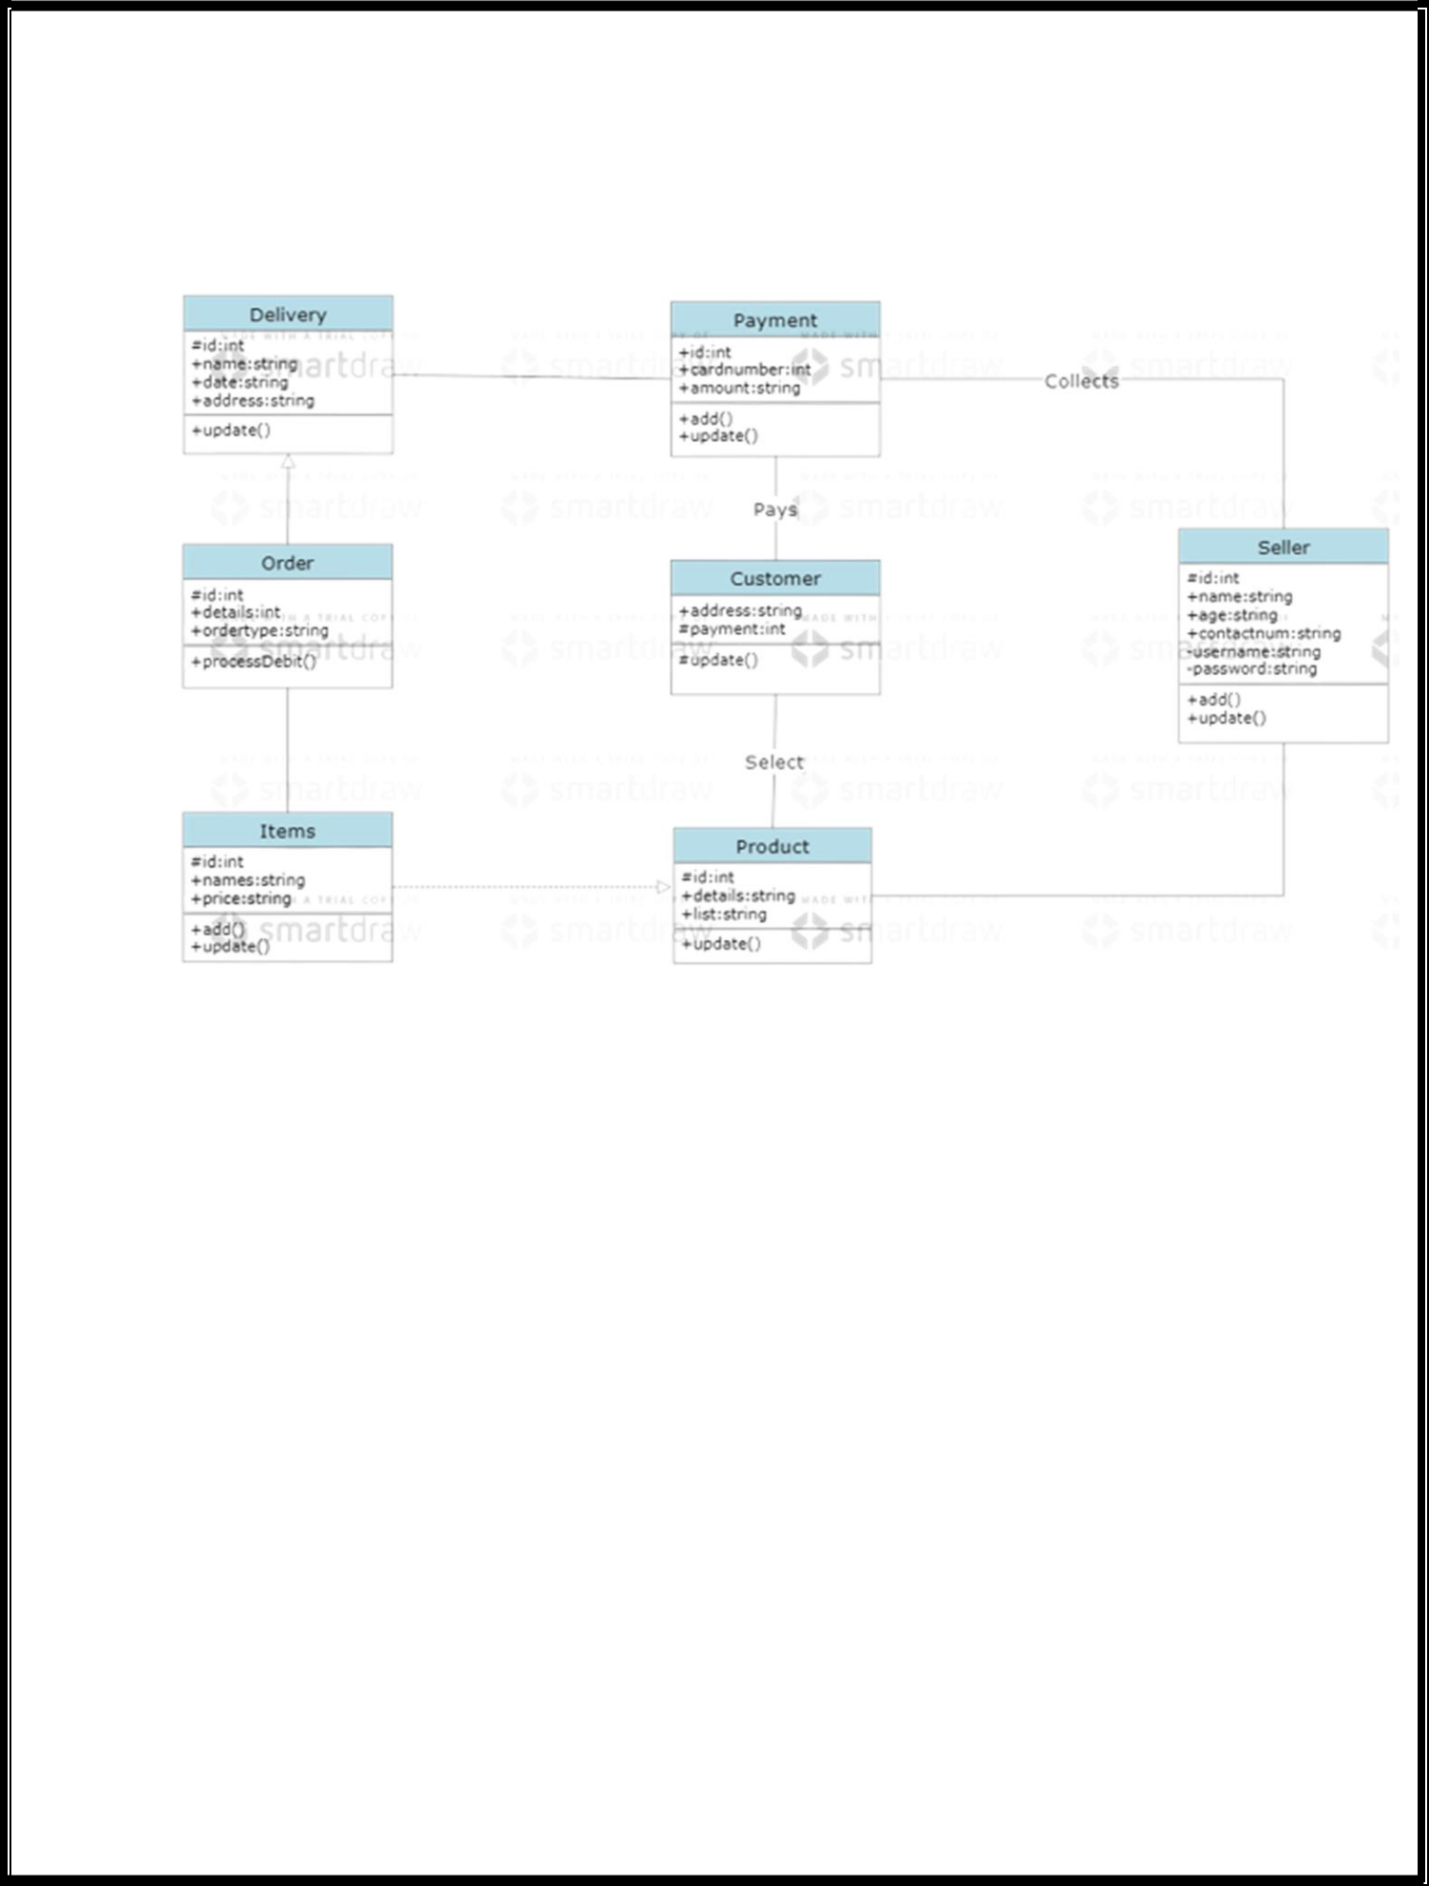

**2.3 Class diagram**

**Fig 2.4**

* A class diagram in the Unified Modeling Language is a type of static structure diagram that describes the structure of a system by showing the system's classes, their attributes, operations, and the relationships among objects.

The purpose of the class diagram can be summarized as −

* Analysis and design of the static view of an application.
* Describe responsibilities of a system.
* Base for component and deployment diagrams.
* Forward and reverse engineeri
* Page



**Chapter 3**

Hardware and Software Requirement

**3.1 Hardware Required**

* **Processor:** Pentium IV or Above
* **RAM :** 2GB or above

✔ **Hard Disk** **:** 50GB or above

* **Input Devices :** Keyboard, Mouse
* **Output Devices:** Monitor

**3.2 Software Required**

**Operating System:** WordPress

**Other Requirements** :- Wifi/Internet Access

**User Experience Level** :- Basic knowledge Of CMS(wordPress)

**Local host:**

XAMPP/WAMP/LAMP/MAMP

Page

**Chapter 4**

**Implementing Tools for the Project**

**3.3 Visual Studio code**

Visual Studio Code is a source-code editor that can be used with a variety of programming languages, including C, C#, C++, Fortran, Go, Java, JavaScript, Node.js, Python, Rust. It is based on the Electron framework, which is used to develop Node.js web applications that run on the Blink layout engine.Visual Studio Code employs the same editor component (codenamed "Monaco") used in [Azure DevOps](https://en.wikipedia.org/wiki/Azure_DevOps_Server) (formerly called Visual Studio Online and Visual Studio Team Services).Out of the box, Visual Studio Code includes basic support for most common programming languages. This basic support includes [syntax highlighting](https://en.wikipedia.org/wiki/Syntax_highlighting), [bracket matching](https://en.wikipedia.org/wiki/Bracket_matching), [code folding](https://en.wikipedia.org/wiki/Code_folding), and configurable snippets. Visual Studio Code also ships with [IntelliSense](https://en.wikipedia.org/wiki/Intelligent_code_completion) for JavaScript, TypeScript, [JSON](https://en.wikipedia.org/wiki/JSON), [CSS](https://en.wikipedia.org/wiki/CSS), and [HTML](https://en.wikipedia.org/wiki/HTML), as well as debugging support for Node.js. Support for additional languages can be provided by freely available extensions on the VS Code Marketplace

**3.4 What’s included in Visual Studio**

Visual Studio code has four primary components. These are:

**Js:** **JavaScript**,often abbreviated as **JS**, is a [programming language](https://en.wikipedia.org/wiki/Programming_language) that is one of the core technologies of the [World Wide Web](https://en.wikipedia.org/wiki/World_Wide_Web), alongside [HTML](https://en.wikipedia.org/wiki/HTML) and [CSS](https://en.wikipedia.org/wiki/CSS). As of 2022, 98% of [websites](https://en.wikipedia.org/wiki/Website) use JavaScript on the [client](https://en.wikipedia.org/wiki/Client_(computing)) side for [webpage](https://en.wikipedia.org/wiki/Web_page) behavior, often incorporating third-party [libraries](https://en.wikipedia.org/wiki/Library_(computing)).

**Spring boot:** Spring Boot is an open source Java-based framework used to create a micro Service. It is developed by Pivotal Team and is used to build stand-alone and production ready spring applications. This chapter will give you an introduction to Spring Boot and familiarizes you with its basic concepts.

**3.5 HTML**

Every webpage you look at is written in a language called HTML. You can think of HTML as the skeleton that gives every webpage structure. In this course, we'll use HTML to add paragraphs, headings, images and links to a webpage.

In the editor to the right, there's a tab called test.html. This is the file we'll type our HTML into. Like any language, it has its own special syntax. A browser's job is to transform the code in test.html into a recognizable webpage! It knows how to lay out the page by following the HTML syntax.

**3.6 CSS**

Cascading Style Sheets (CSS) is a style sheet language used for describing the presentation of a document written in a markup language. Most often used to set the visual style of web pages and user interfaces written in HTML and XHTML, and is applicable to rendering in speech, or on other media. Along with HTML and JavaScript, CSS is a cornerstone technology used by most websites to create visually engaging webpages, user interfaces for web applications, and user interfaces for many mobile applications.

CSS is designed primarily to enable the separation of document content from document presentation, including aspects such as the layout, colors, and fonts. [3] This separation can improve content accessibility, provide more flexibility and control in the specification of presentation characteristics, enable multiple HTML pages to share formatting by specifying the relevant CSS in a separate .CSS file, and reduce complexity and repetition in the structural content.

**3.7 Android Studio**



**Android Studio is the official** [**integrated development environment**](https://en.wikipedia.org/wiki/Integrated_development_environment) **(IDE) for** [**Google**](https://en.wikipedia.org/wiki/Google)**'s** [**Android**](https://en.wikipedia.org/wiki/Android_(operating_system))[**operating system**](https://en.wikipedia.org/wiki/Operating_system)**, built on** [**JetBrains**](https://en.wikipedia.org/wiki/JetBrains)**'** [**IntelliJ IDEA**](https://en.wikipedia.org/wiki/IntelliJ_IDEA) **software and designed specifically for** [**Android development**](https://en.wikipedia.org/wiki/Android_software_development) **It is available for download on** [**Windows**](https://en.wikipedia.org/wiki/Windows)**,** [**macOS**](https://en.wikipedia.org/wiki/MacOS) **and** [**Linux**](https://en.wikipedia.org/wiki/Linux) **based operating systems. It is a replacement for the** [**Eclipse Android Development Tools**](https://en.wikipedia.org/wiki/Eclipse_(software)#Android_Development_Tools) **(E-ADT) as the primary IDE for native Android application development.**

**Android Studio was announced on May 16, 2013, at the** [**Google I/O**](https://en.wikipedia.org/wiki/Google_I/O) **conference. It was in early access preview stage starting from version 0.1 in May 2013, then entered beta stage starting from version 0.8 which was released in June 2014**

**Page 8**

**3.7 Reason for choosing MySQL for developing this website:**

MySQL is a database system used on the web.

MySQL is a database system that runs on a server.

MySQL is ideal for both small and large applications.

MySQL is very fast, reliable, and easy to use.

MySQL uses standard SQL.

MySQL compiles on a number of platforms.

MySQL is free to download and use.

MySQL is developed, distributed, and supported by Oracle Corporation.

The data in a MySQL database are stored in tables. A table is a collection of related data, and it consists of columns and rows. Databases are useful for storing information categorically. PHP combined with MySQL is cross-platform.

**3.8 WordPress**

WordPress is a software which has become the most widely used content management system and is used for setting up blogs.

WordPress allows users to create and edit website through a central administrative dashboard, which includes a text editor for modifying content, menus and various design elements.

**3.9 Themes**

WordPress users may install and switch among many different themes. Themes allow users to change the look and functionality of a WordPress website without altering the core code or site content. Every WordPress website requires at least one theme to be present. Themes may be directly installed using the WordPress "Appearance" administration tool in the dashboard, or theme folders may be copied directly into the themes directory.

**4.0 Plugins**

WordPress' plugin architecture allows users to extend the features and functionality of a website or blog. As of December 2021, WordPress.org has 59,756 plugins available, each of which offers custom functions and features enabling users to tailor their sites to their specific needs. However, this does not include the premium plugins that are available (approximately 1,500+), which may not be listed in the WordPress.org repository. These customizations range

from search engine optimization (SEO), to client portals used to display private information to logged-in users, to content management systems, to content displaying features, such as the addition of widgets and navigation bars.

**Page 9**

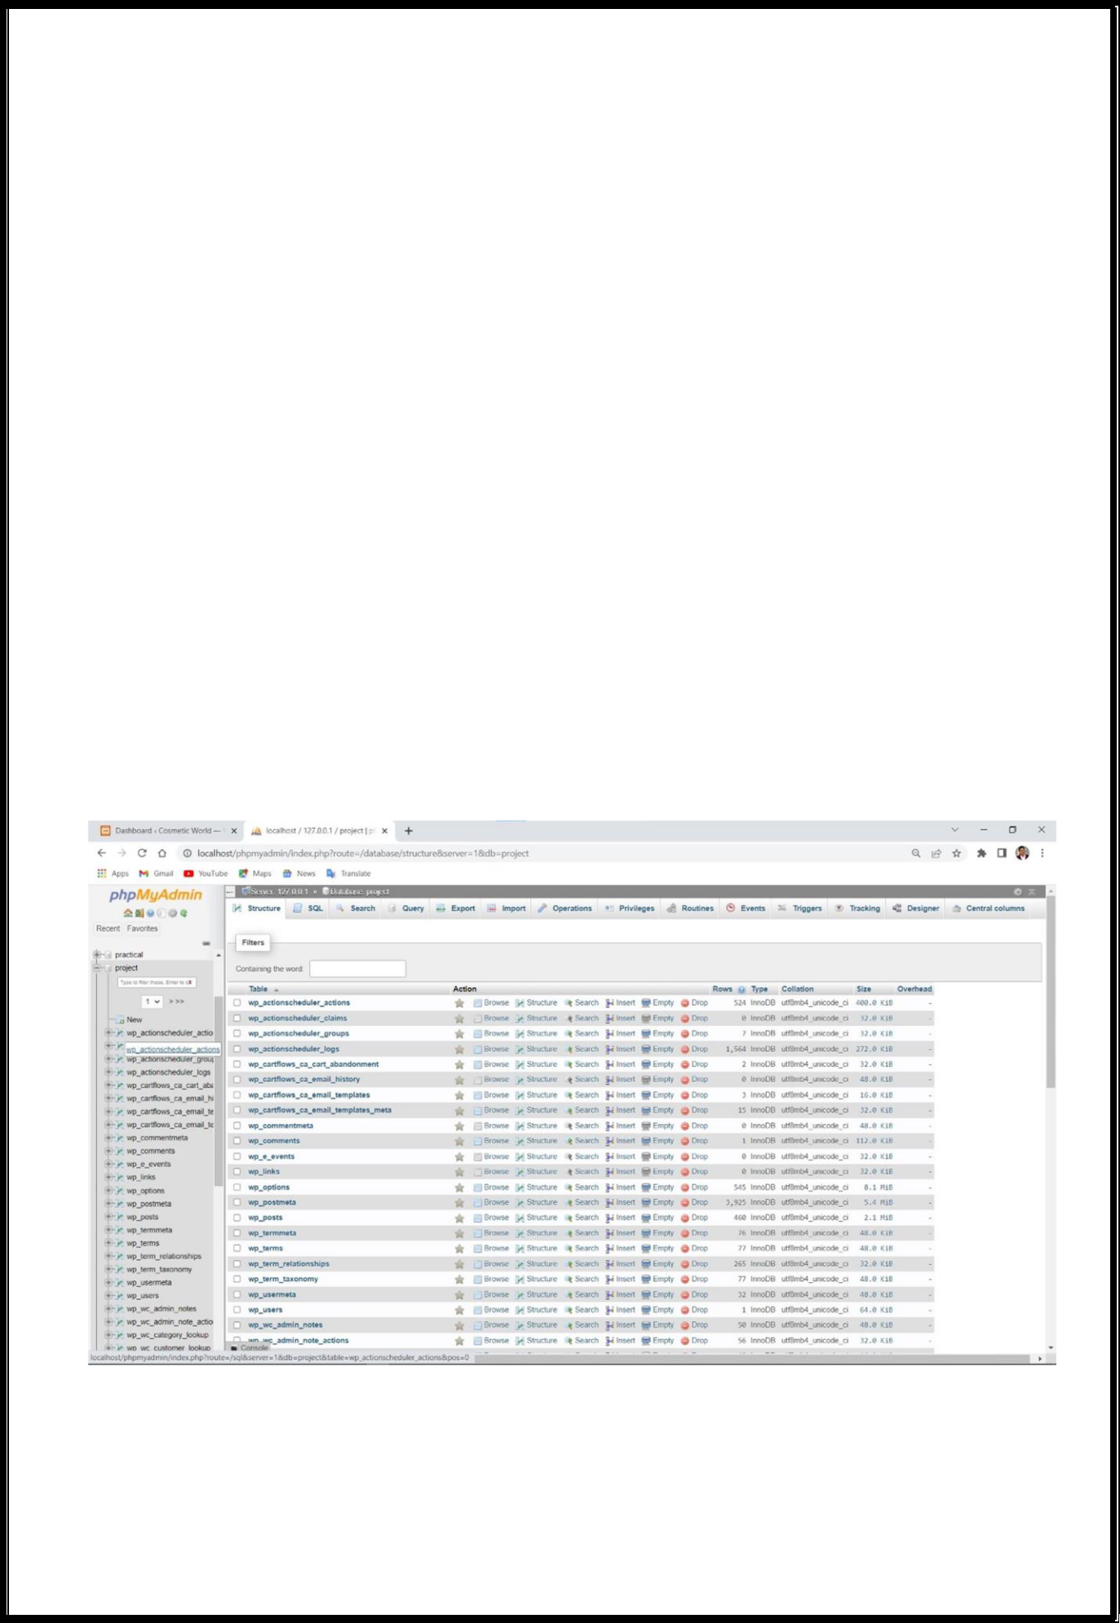

**Chapter 5**

**Project Database and Table**

**5.1 Database Design**

Database is critical for all businesses. A good database does not allow any form of anomalies and stores only relevant information in an ordered manner. If a database has anomalies, it is affecting the efficiency and data integrity. For example, delete anomaly arise upon the deletion of a row which also forces other useful data to be lost. As such, the tables need to be normalized. This fulfils the last objective of ensuring data are accurate and retrieved correctly.

Database files are the key source of information into the system. It is the process of designing database files, which are the key source of information to the system. The files should be properly designed and planned for collection, accumulation, editing and retrieving the required information.

**Database screenshot**

**Page**

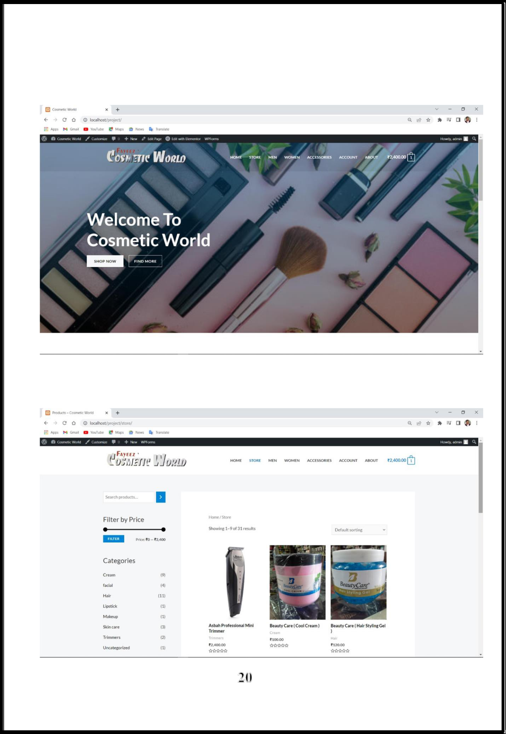

**Chapter 6**

**Screenshots**

**1) Home page**

**6.1 Product Page**

**Page**

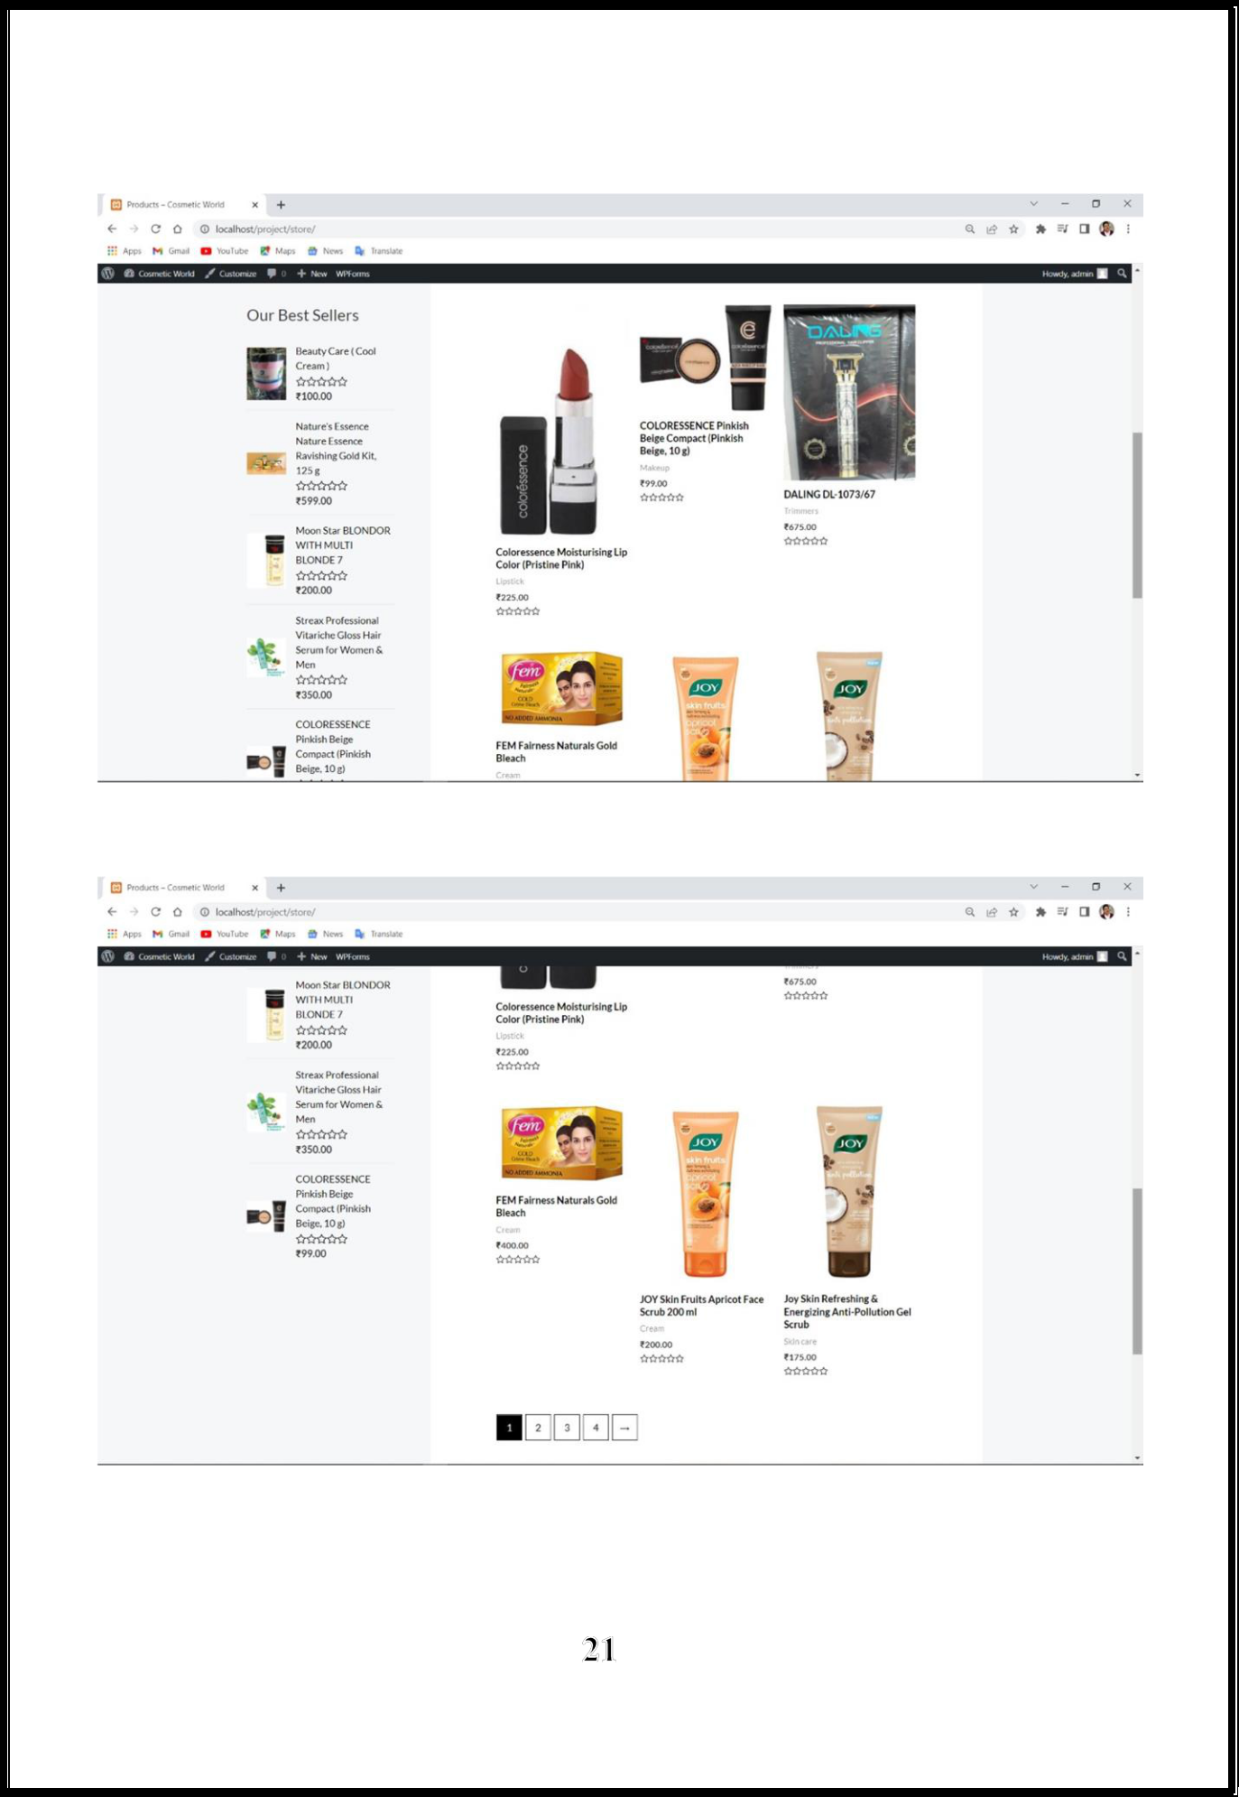

**Page**

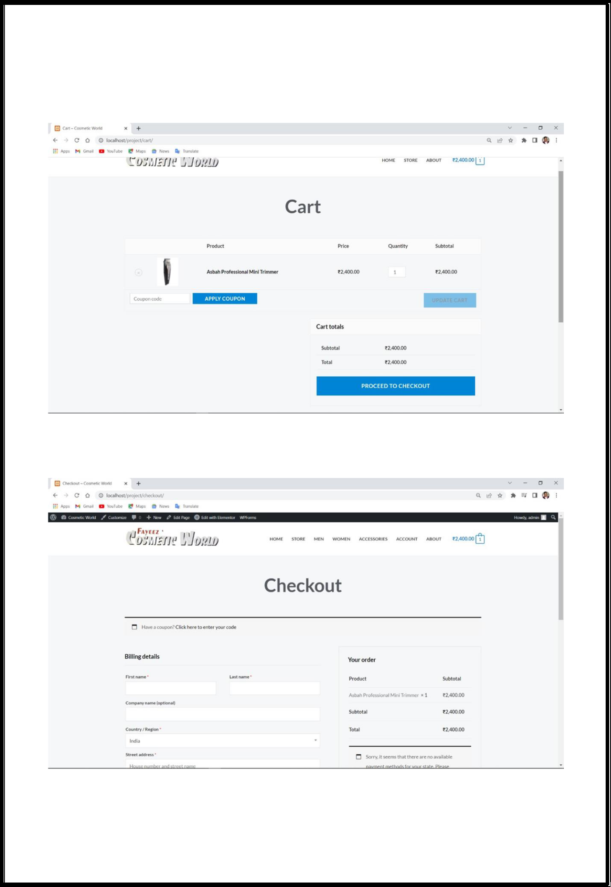

**6.2 Cart page**

**6.3 Checkout page**

**Page**

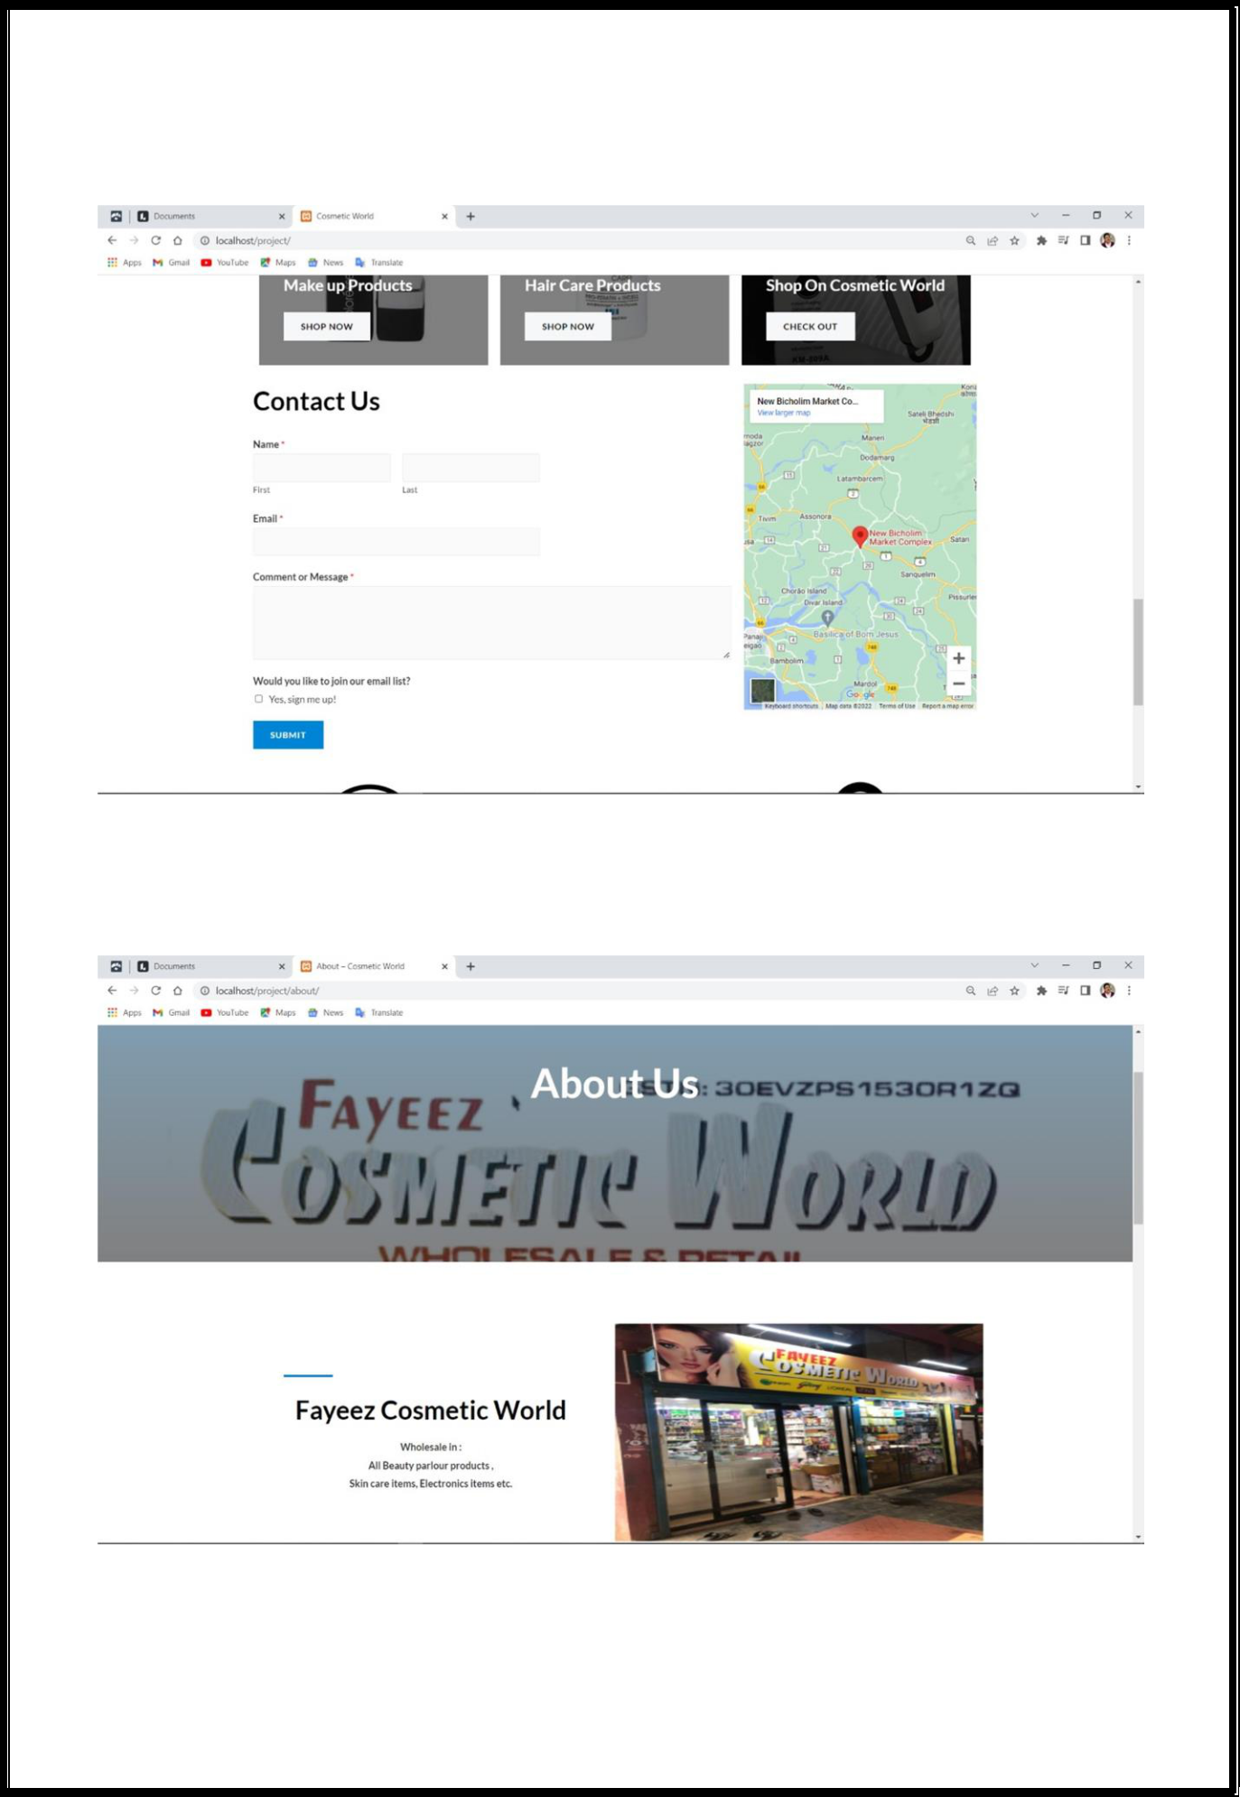

**6.4. Contact us page**

**6.5. About us page screenshot**

**Page**

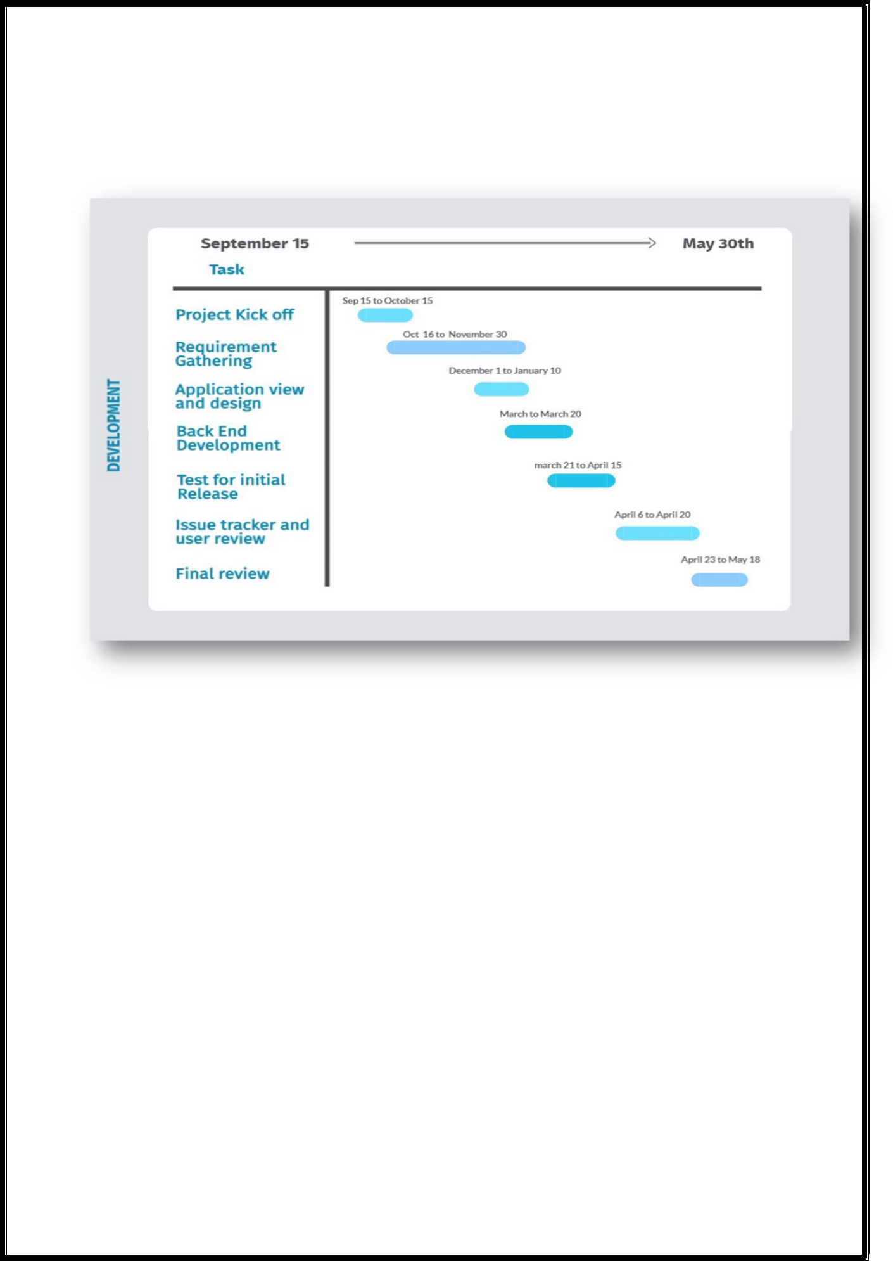**Chapter 7**

**6.6. Gantt chart**

**Fig 6.6**

A Gantt chart is a project management tool that illustrates a project plan. It typically includes two sections: the left side outlines a list of tasks, while the right side has a timeline with schedule bars that visualize work. The Gantt chart can also include the start and end dates of tasks, milestones, dependencies between tasks, and assignees. These roadmap tools help teams maintain a coherent project strategy despite the iterative nature of the software development process.

**Page**



**Chapter 8**

**System Testing**

**6.7 Why System Testing is Needed?**

Tool-bars work properly? Are all menu function and pull down sub function properly listed? Is it possible to invoke each menu function using logical assumptions that if all parts of the system are correct, the goal will be successfully achieved? In adequate testing or non-testing will leads to errors that may appear few months later. Testing represents an interesting anomaly for the software engineer. During earlier software engineering activities, the engineer attempts to build software from an abstract concept to a tangible product. Now comes testing. The engineer creates a series of test cases that are intended to “demolish” the software that has been built. In fact, testing is the one step in the software process that could be viewed (psychologically, at least) as destructive rather than constructive. Testing requires that the developer discard preconceived notions of the “correctness” of software just developed and overcome a conflict of interest that occurs when errors are uncovered.

If testing is conducted successfully (according to the objectives stated previously) it will uncover errors in the software. As a secondary benefit, testing demonstrates that software functions appear to be working according to specification, that behavioral and performance requirements appear to have been met. In addition, data collected as testing is conducted provide a good indication of software reliability and some indication of software quality as a whole. But testing cannot show the absence of errors and defects, it can show only that software errors and defects are present. It is important to keep this (rather gloomy) statement in mind as testing is being conducted.

**6.8 Testing Strategy**

There are types of testing that we implement. They are as follows:

While deciding on the focus of testing activities, study project priorities. For example, for an on- line system, pay more attention to response time. Spend more time on the features used frequently. Decide on the effort required for testing based on the usage of the system. If the system is to be used by a large number of users, evaluate the impact on users due to a system failure before deciding on the effort.



This creates two problems:

1. Time delay between the cause and appearance of the problem.

2)The effect of the system errors on files and records within the system.

The purpose of the system testing is to consider all the likely variations to which it will be suggested and push the systems to limits. The testing process focuses on the logical intervals of the software ensuring that all statements have been tested and on functional interval is conducting test Uncover errors and ensure that defined input will produce actual results that agree with the required results. Program level testing, modules level testing integrated and carried out.



**6.9 Validation Testing**

Validation test report provides the overview of the entire project. Our validation reports include:

* A description of the validation project, including the project scope.
* All test cases performed, including those test cases passed without issue.
* All deviations reported, including how those deviations were resolved.
* Statement which says the system met the defined requirements.

**Page 18**

| **7.0 Validation Testing** | | | **Report** |  |  |  |  |
| --- | --- | --- | --- | --- | --- | --- | --- |
| MODULE | MODULE |  | TEST | TEST | EXPECTED | ACTUAL | PASS |
| NO |  |  | SCENARIO | CASES | RESULTS | RESULTS | / |
|  |  |  | NAME |  |  |  | FAIL |
|  |  |  |  |  |  |  |  |
| 1 | Login |  | Verify user | To test if | User details | Login | Pass |
|  |  |  | details | user | must be | Success |  |
|  |  |  |  | details are | saved |  |  |
|  |  |  |  | being | successfully |  |  |
|  |  |  |  | saved |  |  |  |
|  |  |  |  |  |  |  |  |
| 2 | Add to |  | Verify | To test if | Products | Products | pass |
|  | Cart |  | adding of | items are | must be | added |  |
|  |  |  | products | being | added | successfully |  |
|  |  |  |  | added to | successfully |  |  |
|  |  |  |  | the cart |  |  |  |
|  |  |  |  |  |  |  |  |
| 3 | Search |  | Verify of | To test if | Products | Products | pass |
|  |  |  | search of | items are | must be | added |  |
|  |  |  | products | search | searched | successfully |  |
|  |  |  |  |  | successfully |  |  |
|  |  |  |  |  |  |  |  |
| 4 | Filter |  | Verify filter | To test if | Products | Products | pass |
|  |  |  | of products | items are | must be | filtered |  |
|  |  |  | by price | being | filtered | successfully |  |
|  |  |  |  | filtered by | successfully |  |  |
|  |  |  |  | price |  |  |  |
|  |  |  |  |  |  |  |  |
| 5 | Product |  | Verify | To test if | Products | Product | pass |
|  | page |  | Product | Product | Details | details |  |
|  |  |  | Page | details are | must be | displayed |  |
|  |  |  | details | being | displayed | successfully |  |
|  |  |  |  | dispalyed | successfully |  |  |
| 6 | Payment |  | Verify | To test if | Payment | Payment | pass |
|  | portal |  | payment | Payment | Details | details |  |
|  |  |  | details | method | must be | displayed |  |
|  |  |  |  | and | recorded | successfully |  |
|  |  |  |  | details are | successfully |  |  |
|  |  |  |  | being |  |  |  |
|  |  |  |  | recorded |  |  |  |
| 7 | Product |  | Verify | To test if | Product | Product | pass |
|  | category |  | sorting of | Products | should be | sorted in |  |
|  |  |  | products by | Are being | sorted in | category |  |
|  |  |  | category | successfully |  |
|  |  |  | sorted in | Category |  |
|  |  |  |  | categories | successfully |  |  |
| 8 | Order |  | Verify | To test If | Order | Order | pass |
|  |  |  | ordering of | order | details | details |  |
|  |  |  | item | details | should be | recorded |  |
|  |  |  |  | Are being | recorded | successfully |  |
|  |  |  |  | recorded | successfully |  |  |
|  |  |  |  |  |  |  |  |

**Page 19**

**Test report**

The purpose of doing system integration testing is to verify the behavior of the complete system. It is a testing conducted on a complete integrated system to evaluate the systems compliance with its specified requirements.

The system integration testing for our system is done manually to verify the interactions between the modules of a software system. After validation testing and testing each module we verified if all the modules when integrated work successfully and then verified the high and low level software requirements specified in the software requirement specification.

Before doing the system testing, we first tested all the modules individually and then combined to make a system

The following points describe how system testing was done for our application:

All modules were integrated in advance, and the entire program was tested as a whole. But during this process, a set of errors were encountered.

Correcting those errors was difficult because isolation causes is complicated by the vast expansion of the entire Program.

The errors were rectified and corrected

Black box testing methodology was used.

Test cases were defined using the high level software requirements only.

Repeating tests in the target environment was necessary.

Successful completion of the integration of the software module on the target hardware.

**Page 20**



**Chapter Nine**

**Conclusion & Future Enhancement**

**8.1 Conclusion**

This project is only a humble venture to satisfy the needs in a shop. Several user friendly coding have also adopted. This package shall prove to be a powerful package in satisfying all the requirements of the organization. The objective of software planning is to provide a frame work that enables the manger to make reasonable estimates made within a limited time frame at the beginning of the software project and should be updated regularly as the project progresses.

This website offers a computerised version of a store management system that will assist both the shop's users and visitors. It takes the entire process online, allowing customers to browse for and purchase a variety of products. It also provides a feature for common users to login into the system and view the status of their orders, as well as request products or make ideas. It has an admin login feature that allows administrators to add various items, review user activity, offer occasional discounts, and provide information about various events to customers.

**8.3 Future aspect**

The initiative has immense potential for the years to come. The project might at some point in the future be carried out on an intranet. As a result of its adaptability in terms of extension, the project will be able to be improved in the not-too-distant future as

and when the occasion calls for it. Since the intended database Space Manager software is now ready and completely functional, the client is now able to control and therefore run the entire task in a manner that is significantly better, accurate, and error-free than it was before possible.

The following are the future scope for the project.

* Should be added payment gateway
* Can be added inventory management system
* Can be added multiple branches
* Can be added multilingual to this site
* And many features can be added this project to make it more robust.

**Page 21**